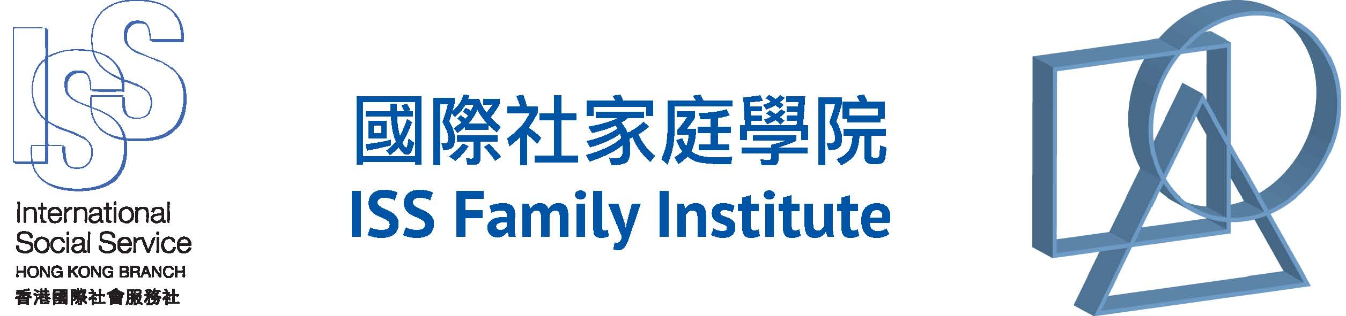

Please read the notes below for enrolment.
We accept payment by cash, cheque and direct bank transfer. If you wish to pay by cheque or direct bank transfer, please have the cheque or bank-in slip ready before you fill in the form as cheque number or bank-in slip reference number is required.
Payment method:
- Cheque
Please make your cheque payable to "International Social Service Hong Kong Branch", write your name, contact phone number, programme name and code at the back of the cheque and mail it to us.
- Bank transfer
Please make deposit to the bank account of "International Social Service Hong Kong Branch" via automatic teller machines (ATM) / bank teller / the internet banking. Please send the bank pay-in slip or a copy of transaction record to us by post or email with your name, contact phone number, programme name and code.
ISS-HK Account: HSBC (Bank code 004) 028-003622-001
- Cash
Pay by cash in person at 6/F, Southorn Centre, Wanchai, Hong Kong during office hours from Monday to Friday.
Mon: 9am-1pm / 2pm-6pm
Tue-Fri: 9am-1pm / 2pm-5pm
Sat, Sun & Public holiday: Closed

ENROLLMENT
We accept payment by cash, cheque and direct bank transfer. If you wish to pay by cheque or direct bank transfer, please have the cheque or bank-in slip ready before you fill in the form as cheque number or bank-in slip reference number is required.
* Mandatory Fields
COURSE INFORMATION
Course Name*: _________________________________________
Course Code*: _________________________________________
Fee*: HK$______________

Payment Method*
Cheque
Cheque No.: _________ / Name of bank: _________________________

Bank transfer
Date of payment: ________________
Bank-in Slip Reference Number: ________________________

Cash
APPLICANT'S INFORMATION
Are you a member of ISSFI Circle of Friends (COF)?*
Yes (COF No.: ____________)
No

Title*: Mr / Mrs / Ms / Not Applicable
Name (Chinese)*: ______________________________________
Name (English)*: First Name _____________________________
Surname:- _____________________________
Employer*: _____________________________________________
Type of Service*: ________________________________________
Post*: _________________________________________________

Education Level*
Secondary School
Post-secondary
Degree of Bachelor
Degree of Master or above
Others (Please Specify: ________________________________)

Corresponding Address*:
_______________________________________________________
_______________________________________________________

Tel*: (Office) ____________________
(Home) ____________________
(Mobile) ___________________
Fax: __________________________
Email*: _____________________________________________________

Have you attended other ISSFI course before?*
Yes (Please Specify _____________________________)
No

Name on Receipt (in English)*
Name of Organization _______________________________________
Your Name

How did you hear about our programmes?*
Our Website
Our Facebook
Friends
Media
Others (Please Specify ______________________________________)

I do not wish to receive ISS-HK e-Newsletters
I do not wish to receive promotional materials of ISSFI's programmes and activities

Notes:
- Application will be accepted on first-come-first-served basis.
- Fees paid are not refundable unless the enrolled programme is full or cancelled.
- If Storm Warning Signal No.8 or above, or Black Rainstorm Warning Signal is hoisted, the lesson will be cancelled. Details of postponement or other arrangements will be announced afterwards.
- Receipt of application fee will be issued on the first day of the course.
- A Certificate of Attendance issued by International Social Service Hong Kong Branch will be given to those who complete at least 80% of the programme with more than 3 classes.
- Photos or videos may be taken during the programme, and be used for promotion of the Institute’s services. If there is disagreement about this, please inform the Institute by writing.
- The personal data provided on this form is used by the Institute only for enrolment and administration purposes (and for sending promotional materials of the ISS-HK / ISSFI programmes and activities if you have not checked the tick box indicating objection for us to do so). Under the provision of the Personal Data (Privacy) Ordinance, applicants have the right to request access to and make correction of their personal data. Please write to us to make the request. You may refer to our privacy policy (http://www.isshk.org/en-us/privacy-policy) for details.

Tel.: 28346863
Fax: 28347627
Email: issfi@isshk.org
Address: ISS-HK, 6/F, Southorn Centre, 130 Hennessy Road, Wanchai, Hong Kong

